
HYPER Universal Mud Flap kit

(please note these do not fit the Suzuki LTF/LTA400 2008 King Quad )

Part Number 145.0100

DESCRIPTION
The HYPER Mud Flaps offer protection to trailed equipment from mud splatter and have been designed to fit a wide range of ATVs.

CONTENTS

NOTES
- Each mud flap is supplied in a 650x350 rectangle. You will need to drill holes for mounting the long bracket and if necessary, trim the flap to avoid clashing with ATV’s exhaust.
- This kit is designed to fit a number of different ATVs and as such, you will have spare brackets and fasteners left over.
- Loosely fit all screws and nuts then fully tighten once installation is complete.

INSTALLATION

Standard Mounting
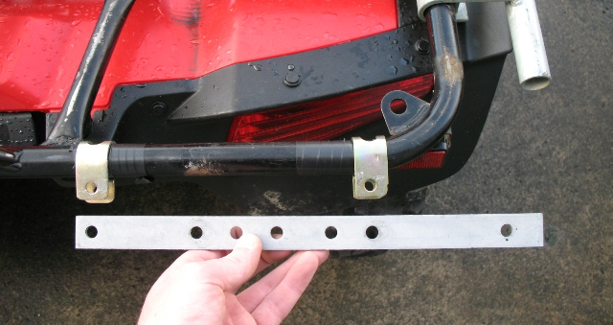  Flat side  Holes line up | Visually position the long mudflap bracket in a position that provides good coverage from mud splatter.  Fit 2 p-clips per mudflap to the rear carrier rail in a place that lines up with 2 corresponding holes in the long mudflap bracket. Ensure the p-clips are orientated with the ‘flat’ side facing towards you.
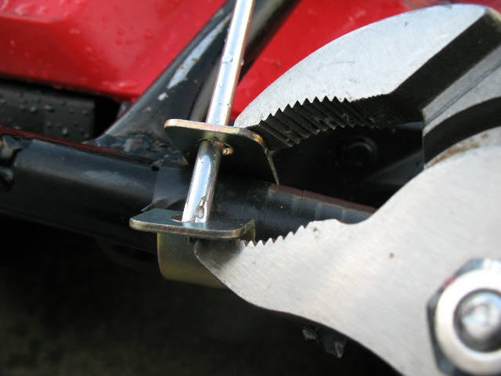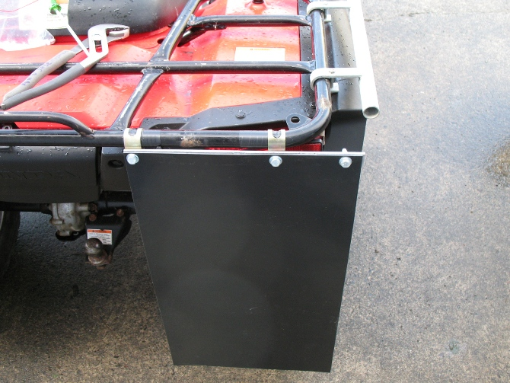
Insert a screwdriver through the two holes in the p-clip, squeeze the p-clip together using a pair of polygrips (the screwdriver will ensure the holes are lined up once released).

Drill 3 holes in the mudflap (2 that line up with the p-clips and 1 on the outside). Attach the mudflap and the long bracket to the p-clips using M8x25 screws, washers and M8 Nyloc Nuts.
Note: The Honda 500 has a 25mm rear carrier, use the M8x40 screws in place of the M8x25 screws.

QuickSmart Mounting
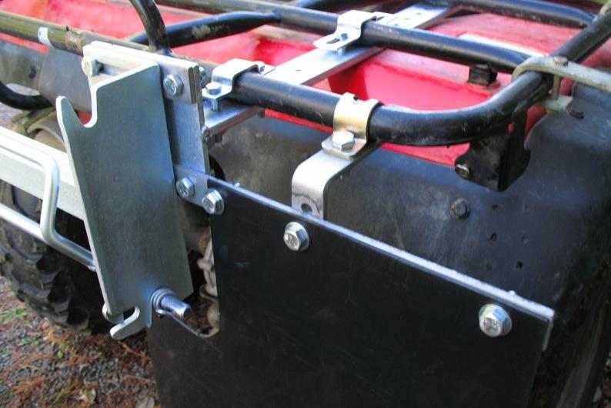  (A)  (B)  (D) | Mount the QuickSmart arms to the ATV.  Insert brackets (A) and (B) as shown.  Mount the QuickSmart frame to the arms using the inside holes only.  Extra support can be achieved by mounting bracket (D) – (the larger of the 2 L-shaped brackets) as shown. Note: If mounting to a Honda TRX420, the p-clamp will need to be rotated 180˚.  Cut a section from each mud flap as indicated on the photo.  Drill the necessary holes in each mud flap and mount using the fasteners provided.

Honda TRX420 Mounting
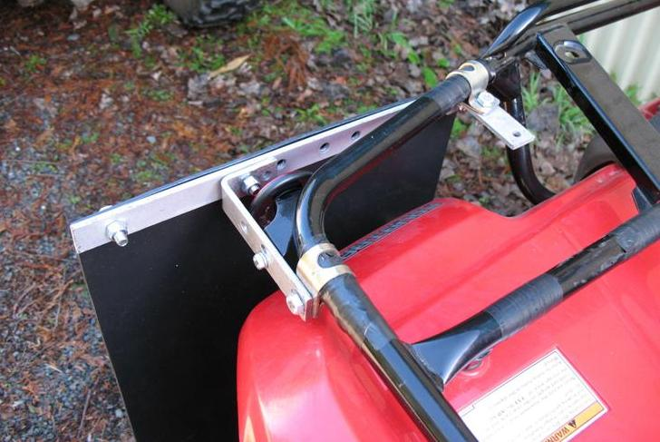  (A)  (D)  (C)  Large space  Outside of ATV | The TRX420 has an angled rear carrier rail that requires a unique mounting method.  Remove the side reflector. Attach bracket (D) – (the larger L-shaped bracket) using a p-clamp to the side of the carrier.  Mount bracket (C) – (the smaller L-shaped bracket) to the rear carrier rail as shown.  Mount the long bracket (A) to the 2 L-shaped brackets. Ensure the large sp space between the hole and edge is to the outside of the ATV(see photo).  Using an M6 screw and spring washer, locate bracket (D) through the bottom  hole of the reflector mount.
Drill the necessary holes in each mud flap and mount using the fasteners provided.


